# ABC’s Inventory Management System

## Log Out Test Script

|  |  |  |  |  |  |
| --- | --- | --- | --- | --- | --- |
| **Test Name** | | Test Log Out Function | | | |
| **Use Case Tested** | | Log In/ Out | | | |
| **Test Description** | | This test tests if the system can log out from the home page | | | |
| **Pre-Conditions** | | Meta data must exist, users signed in to the system. | | | |
| **Post-Conditions** | | System direct to the log in page | | | |
| **Notes** | | This test assumes that the user knows the username and password exists. | | | |
| **Result (Pass/Fail/Warning/ Incomplete)** | | Pass | | | |
|  | **Test Step** | | **Expected Test Results** | **P** | **F** |
| 1. | Open the ABCInventoryClient.exe file | | ABCInventoryClient system launches. | P |  |
| 2. | Type in the existing username and password that is known by the user. | | System waits for the user to hit enter or click on the ‘Log In button. | P |  |
| 3. | Hit enter or click on the ‘Log In button. | | Username with matching username and password is displayed with all other functionality base on the staff role. | P |  |
| 4. | Hit enter or click on the ‘Log out’ Button on the top-right corner | | System direct to the log in page. | P |  |

|  |  |  |
| --- | --- | --- |
| **Test Data Table** | | |
|  | **Username** | **Password** |
| **1** | hanh | hanh |

# Result Screenshots

The screenshots of the result on each test step for each data set are given below:

## Data Set 1

**Step 1**

User launches the ABC Inventory Management System

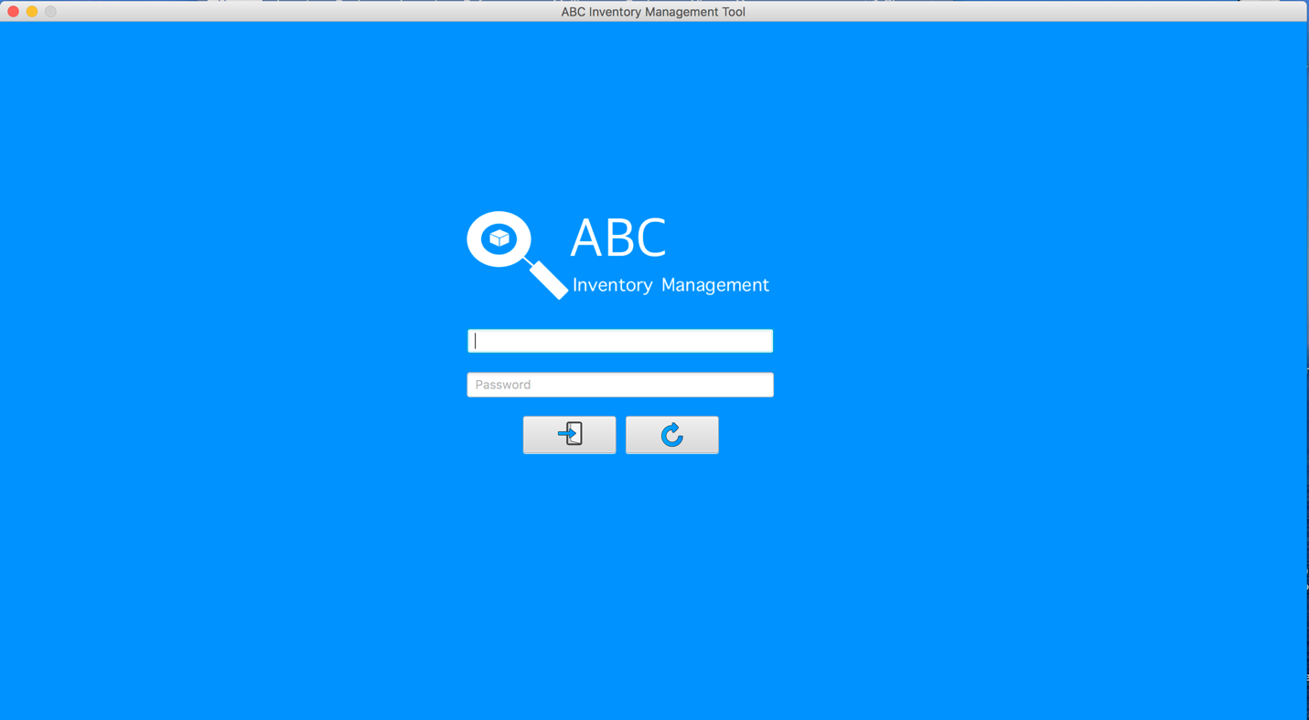

**Step 2**

User enter the correct username and password

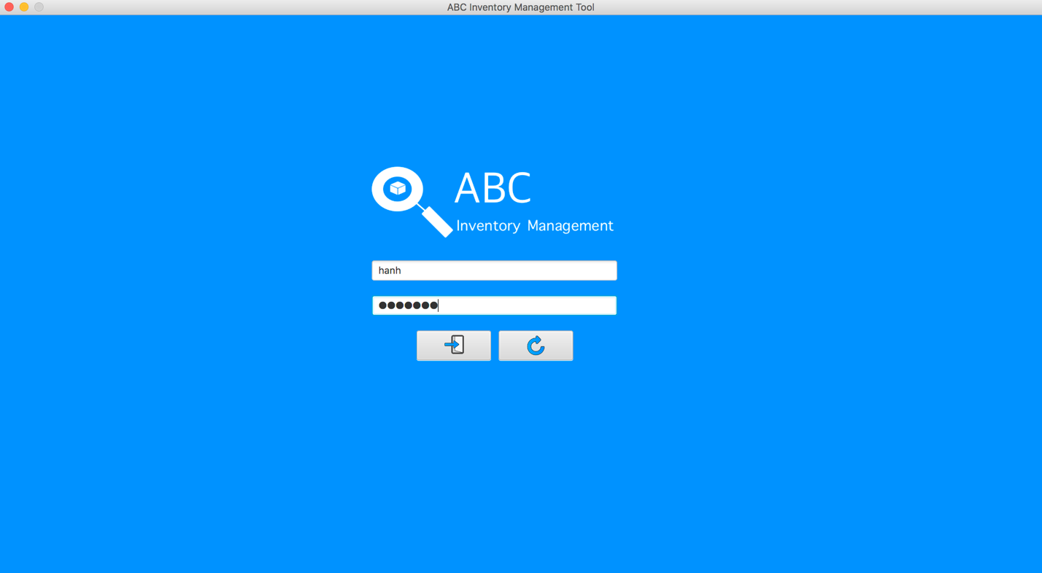

**Step 3**

System direct to the homage which contains the main function

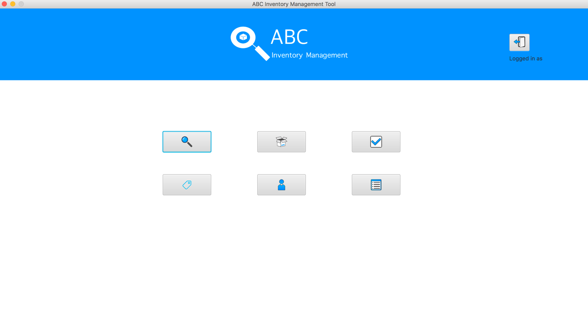

**Step 3**

System direct to the login page when ‘Log out’ Button was pressed

